**DIP CA2 Report 趙新元 b10505057**

**1.**

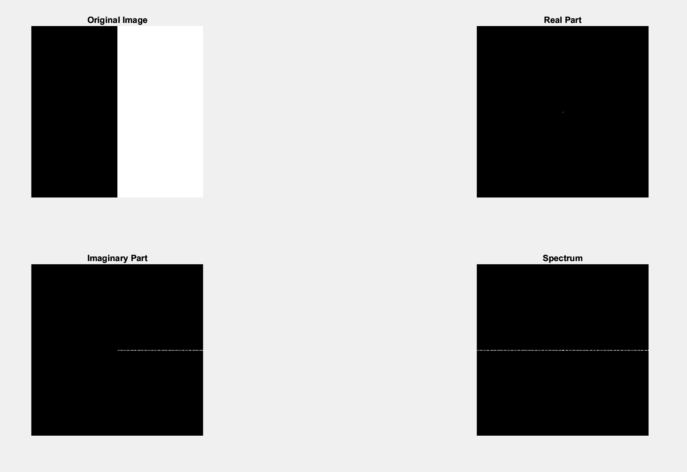 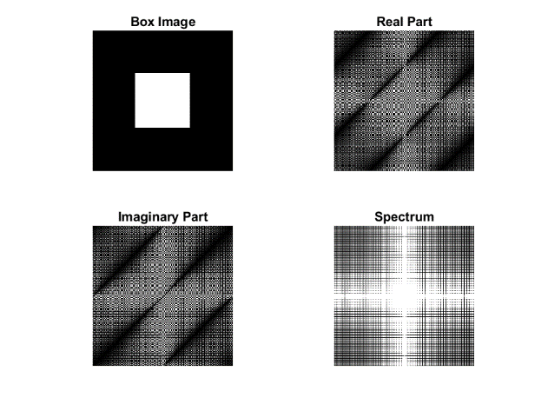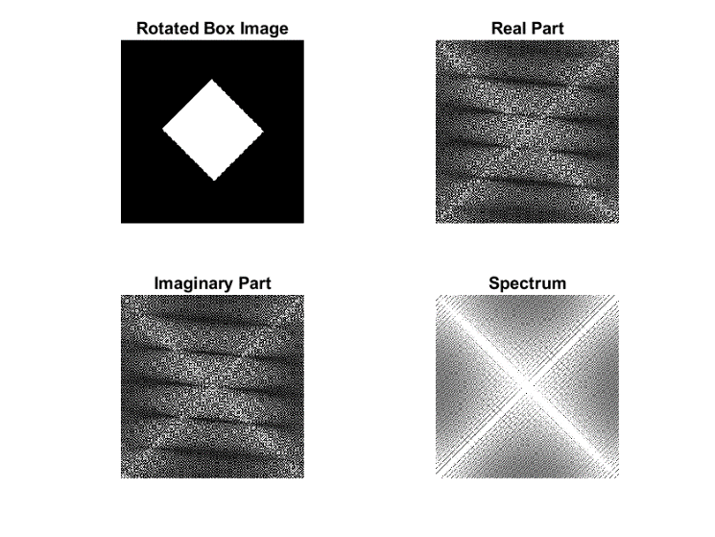 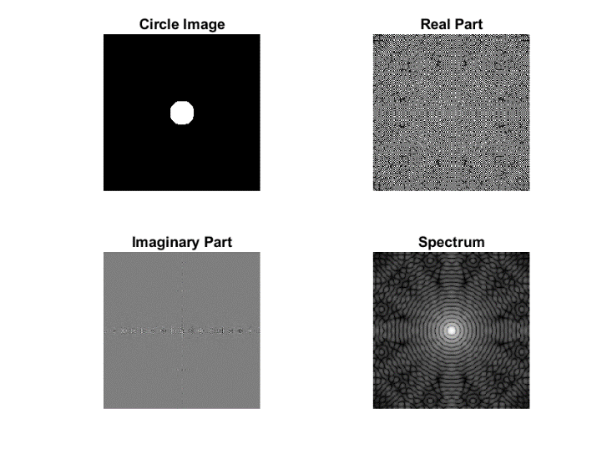

**2.**

Lowpass filtering with cutoff of 5: Preserves low-frequency details.

Lowpass filtering with cutoff of 30: Preserves more details but smooths the image.

Highpass filtering with cutoff of 5: Enhances high-frequency details.

Highpass filtering with cutoff of 30: Preserves more high-frequency details.

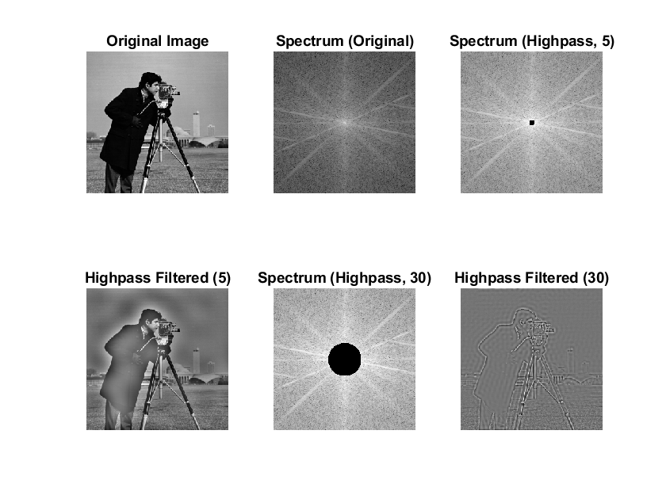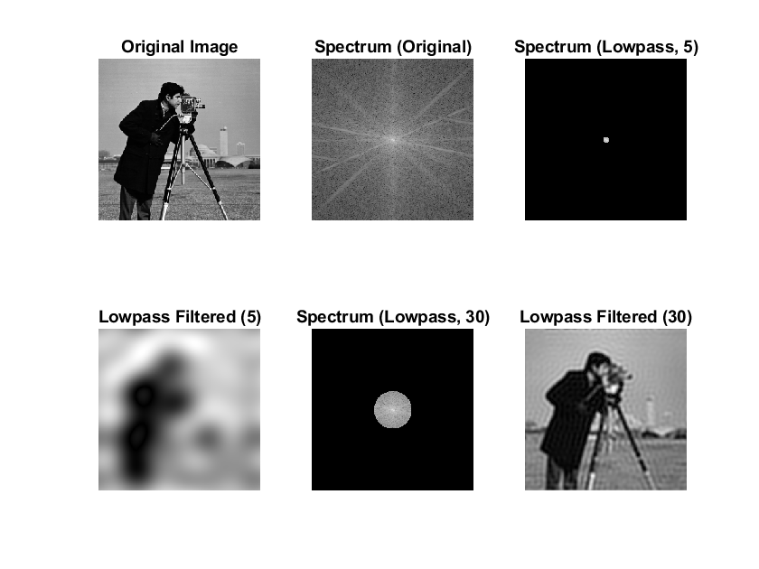

**3.**

Lowpass filtering with smaller sigma (10) preserves more high-frequency details.

Lowpass filtering with larger sigma (30) results in more blurring.

Highpass filtering with smaller sigma (10) enhances high-frequency details.

Highpass filtering with larger sigma (30) results in more pronounced high-frequency enhancement.